MicroprocessorS PROJECT REPORT
Radar System
Using 8051 Microcontroller
Ultrasonic Proximity Detection System

SUBMITTED BY | Marwan Hossam — 231005406  Ahmed ElSayed — 231006905  Ahmed Gamal — 231004245

June 2026

1. Abstract
This project presents the design and implementation of an ultrasonic distance measurement system — referred to as a Radar System — using the AT89S52 microcontroller. The system employs an HC-SR04 ultrasonic sensor to measure distances ranging from 2 cm to 200 cm, displays real-time readings on a 16×2 LCD, and provides visual and audible feedback through LEDs and a buzzer. The system is programmed in Assembly language using the ASEM-51 assembler and flashed onto the microcontroller via AVRDUDE with an Arduino UNO acting as an ISP programmer.

2. Introduction
Distance measurement is fundamental in many engineering domains, including robotics, industrial automation, parking assistance, and security systems. Ultrasonic sensors provide a non-contact, cost-effective approach to distance measurement. This project demonstrates a complete embedded system that measures distance and provides multi-level feedback based on predefined thresholds.

2.1 Objectives
- Measure distance from 2 cm to 200 cm using the HC-SR04 ultrasonic sensor
- Display real-time distance readings on a 16×2 LCD
- Provide visual indication via three LEDs (Green, Yellow, Red) based on distance ranges
- Activate an audible buzzer for critical distances (less than 10 cm)
- Implement a complete embedded system using the AT89S52 microcontroller

3. System Components

3.1 Hardware Components
Component | Specification | Qty
AT89S52 Microcontroller | 8-bit, 8KB Flash, 11MHz Crystal | 1
HC-SR04 Ultrasonic Sensor | 2cm–400cm range, 40kHz | 1
16×2 LCD Display | HD44780 Compatible | 1
Green LED | 5mm | 1
Yellow LED | 5mm | 1
Red LED | 5mm | 1
Buzzer | 5V Active | 1
Resistors | 220Ω (LEDs), 10kΩ (pull-ups) | 10
Potentiometer | 10kΩ – LCD Contrast | 1
Power Supply | 5V DC | 1
Arduino UNO | ISP Programmer | 1

3.2 Software Tools
Tool | Version | Purpose
ASEM-51 | V1.3 | Assembly language compiler
AVRDUDE | 8.0.0 | Microcontroller programmer
ArduinoISP | — | Programmer firmware for Arduino UNO

4. System Architecture

4.1 Pin Connections
The AT89S52 interfaces with all peripherals as described in the tables below.

4.1.1 HC-SR04 Ultrasonic Sensor
HC-SR04 Pin | Connected To
VCC | +5V
GND | GND
TRIG | P1.0
ECHO | P1.1

4.1.2 LCD Display (4-bit Mode)
LCD Pin | Function | Connected To
1 | VSS | GND
2 | VDD | +5V
3 | V0 (Contrast) | Potentiometer / GND
4 | RS | P2.4
5 | RW | GND
6 | EN | P2.5
11 | D4 | P2.0
12 | D5 | P2.1
13 | D6 | P2.2
14 | D7 | P2.3
15 | LED+ | +5V (via 220Ω)
16 | LED- | GND

4.1.3 LEDs and Buzzer
Component | Connected To | Active State
Green LED (Anode) | +5V via 220Ω → Cathode to P3.3 | LOW = ON
Yellow LED (Anode) | +5V via 220Ω → Cathode to P3.4 | LOW = ON
Red LED (Anode) | +5V via 220Ω → Cathode to P3.5 | LOW = ON
Buzzer (+) | +5V → (–) to P2.6 | LOW = ON

5. Working Principle

5.1 Ultrasonic Distance Measurement
The HC-SR04 sensor operates on echo-timing principles:
- A 10 µs HIGH pulse is sent to the TRIG pin
- The sensor emits 8 cycles of 40 kHz ultrasonic sound
- Sound waves reflect off objects and return to the sensor
- The ECHO pin goes HIGH when sound is emitted and LOW when the echo is received
- The ECHO pulse width is directly proportional to the measured distance

5.2 Distance Calculation Formula
The microcontroller's Timer 0 (Mode 1, 16-bit) measures the ECHO pulse width. The timer value is then divided by 58 to obtain distance in centimeters:

Distance (cm) = Echo Pulse Width (µs) ÷ 58

Where: Speed of Sound = 343 m/s = 0.0343 cm/µs, divided by 2 for the round trip.

5.3 Feedback Logic
Distance Range | Green LED | Yellow LED | Red LED | Buzzer | LCD Warning
> 30 cm | ON | OFF | OFF | OFF | —
20 – 30 cm | OFF | ON | OFF | OFF | —
10 – 20 cm | OFF | OFF | ON | OFF | —
< 10 cm | OFF | OFF | ON | ON | <10cm!

5.4 Hardware Implementation

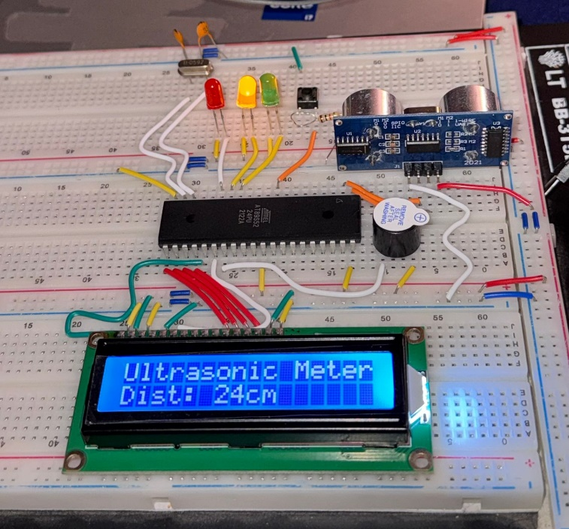

6. Software Implementation

6.1 Program Schematic

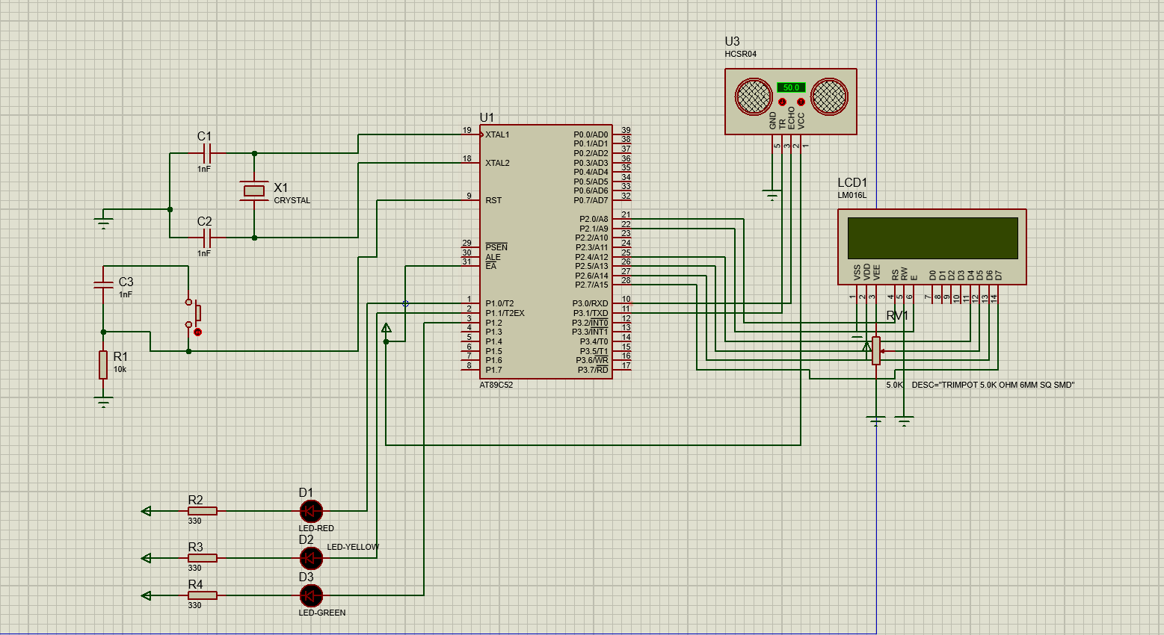

The program follows a straightforward sequential loop:
- Timer 0 initialization and LCD initialization on startup
- Display static header on LCD
- Enter main loop: measure distance → update display → control LEDs → control buzzer → 200 ms delay

6.2 Key Functions
Function | Description
MEASURE_DISTANCE | Triggers HC-SR04 and measures ECHO pulse width via Timer 0
DIV_58 | Converts raw timer value to distance in centimeters
UPDATE_DISPLAY | Updates LCD only when distance value changes
CONTROL_LEDS | Sets LED states based on distance thresholds
CONTROL_BUZZER | Activates buzzer when distance < 10 cm
LCD_INIT | Initializes LCD in 4-bit mode with required timing
LCD_CMD / LCD_DATA | Sends commands or character data to LCD
LCD_STRING | Displays a null-terminated string from code memory

6.3 Timing Calculations (11 MHz Crystal)
- Machine cycle = 12 × clock cycle = 12 / 11 MHz ≈ 1.09 µs
- Delay loops calibrated for 1 ms, 5 ms, 10 ms, 50 ms, 100 ms, and 200 ms
- 10 µs delay used for HC-SR04 trigger pulse

7. Testing and Results
Test Case | Expected Result | Status
Distance > 30 cm | Green LED ON | Pass
Distance 20–30 cm | Yellow LED ON | Pass
Distance 10–20 cm | Red LED ON | Pass
Distance < 10 cm | Red LED ON + Buzzer + LCD Warning | Pass
LCD Display | Correct real-time distance reading | Pass
Measurement Range | 2 cm to 200 cm | Pass

8. Challenges and Solutions

8.1 LCD Initialization
Challenge: LCD displaying garbage characters or blank screen.
Solution: Grounded the RW pin for write-only operation.

8.2 Timing Accuracy
Challenge: Inconsistent distance readings due to timing errors.
Solution: Calibrated delay loops for the exact 11 MHz crystal, applied Distance = Time / 58 formula, and added timer overflow protection.

8.3 LED Polarity
Challenge: LEDs toggling with incorrect logic (wrong polarity).
Solution: Identified common-anode configuration (LED+ to +5V), inverted control logic (CLR = ON, SETB = OFF), and updated the code accordingly.

9. Applications
This system can be applied in a variety of real-world scenarios:
- Robotics — Obstacle detection and avoidance
- Parking Assistance — Vehicle reverse guidance
- Industrial Automation — Liquid level monitoring
- Security Systems — Motion and intrusion detection
- Smart Homes — Automatic doors and occupancy-based lighting
- Education — Embedded systems demonstration and teaching tool

10. Conclusion
The Radar System project successfully demonstrates the implementation of a complete embedded system using the AT89S52 microcontroller. The system reliably measures distances from 2 cm to 200 cm, displays readings on a 16×2 LCD, and delivers multi-level visual and audible feedback.

All project objectives were achieved:
- Real-time distance measurement with up to 2% error at long range
- LCD display with live updates
- Three-zone LED indication (Green / Yellow / Red)
- Buzzer alert for critical proximity (< 10 cm)

The system is reliable, cost-effective, and extensible for various real-world applications. It serves as a solid foundation for understanding microcontroller programming, sensor interfacing, and embedded system design.

11. Bill of Materials
Component | Part / Spec | Cost(egp)
AT89S52 Microcontroller | AT89S52-24PU | 100
HC-SR04 Sensor | HC-SR04 | 70
16×2 LCD Display | LM016L | 80
LEDs (3 pcs) | 5mm Green / Yellow / Red | 2.5
Buzzer | 5V Active Buzzer | 5
Resistors (10 pcs) | 220Ω & 10kΩ | 2.5
Crystal Oscillator | 11.0592 MHz | 5
Documentation Report |  | 30
Total |  | 300

12. References
- AT89S52 Datasheet — Atmel / Microchip Technology
- HC-SR04 Ultrasonic Sensor Datasheet
- HD44780 LCD Controller Datasheet
- ASEM-51 Assembler Documentation
- AVRDUDE User Manual

